Tetrahedron Letters
Volume 47, Issue 5, 30 January 2006, Pages 711–714

A facile one-pot synthesis of 8-oxo-7,8-dihydro-(2′-deoxy)adenosine in water
- Chryssostomos Chatgilialogluª,
- Maria Luisa Navacchia^{a, ,} ,
- Al Postigo^{b}

Abstract
Reaction of 2-mercaptoethanol with 8-bromo-2′-deoxyadenosine and 8-bromo-adenosine in aqueous solution and in the presence of triethylamine gave the 8-oxo-adenine derivatives in very good yields. Some mechanistic details are reported.
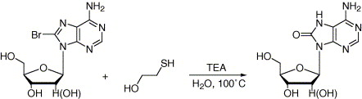

Keywords
- DNA damage;
- Nucleosides;
- 8-Oxo-7,8-dihydro-2′-deoxyadenosine;
- Mercaptoethanol;
- 8-Bromo-2′-deoxyadenosine
Corresponding author. Tel.: +39 051 6398291; fax: +39 051 63983491.
Copyright © 2005 Elsevier Ltd. All rights reserved.

Chryssostomos Chatgilialoglu
ISOF, Consiglio Nazionale delle Ricerche, Via P. Gobetti 101, 40129 Bologna, Italy

Maria Luisa Navacchia
ISOF, Consiglio Nazionale delle Ricerche, Via P. Gobetti 101, 40129 Bologna, Italy
Corresponding author. Tel.: +39 051 6398291; fax: +39 051 63983491.
M.L.Navacchia@isof.cnr.it

Al Postigo
University of Belgrano-Conicet, Villanueva 1324, 1426, Buenos Aires, Argentina

